# Adding New Unit Test File

Create your unit tests in a separate file under under **rin/web/tests** folder.   
Add the file to **rin/web/tests/RINUnitTest.html** in the below format

<script type="text/javascript" charset="utf-8" src="core/MyTests.js"></script>

Note: If your test/module requires any libraries, then it should also be included.

# Adding a new test module

Define a module for your test using the below method call for easier access to your tests.  
module("My Custom Tests");

# Adding New Synchronous Test

If your unit-test runs synchronously, define the unit-test in the below format

test("Unit Test Name Or ID", function () {

//Insert unit-test data here

//Insert Steps for test

//Insert assertions using ok() or equal() etc..

More assertions at : <http://api.qunitjs.com/category/assert/>

});

***Sample: core/BCL.Tests.js***

# Adding New ASynchronous Test

If your unit-test runs asynchronously (i.e. test to be run in callback or after some event), define the unit-test in the below format

asyncTest("Unit Test Name Or ID", function () {

//Insert unit-test data here

//Insert Steps for test

//Wait for event to complete

//Insert assertions using ok() or equal() etc..

More assertions at : <http://api.qunitjs.com/category/assert/>

//Start the test using start() after the pre-requisites

start();

});

***Sample: core/*** ***TransitionService.Tests.js***

# Running Unit Tests

Set **rin/web/tests/RINUnitTest.html** as the start page.

Run the solution. All the tests would run.

## Re-running a specific module

To Rerun all under tests under a specific module. Select the module from the drop-down

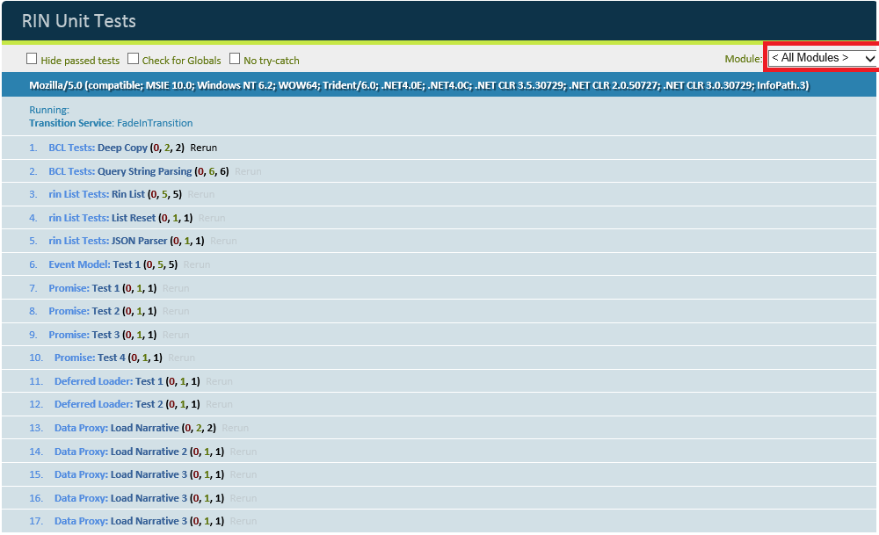

## Re-run a specific test

To Rerun any passed or failed test. Click on Re-run button next to the test-name. Only that test would be executed.  
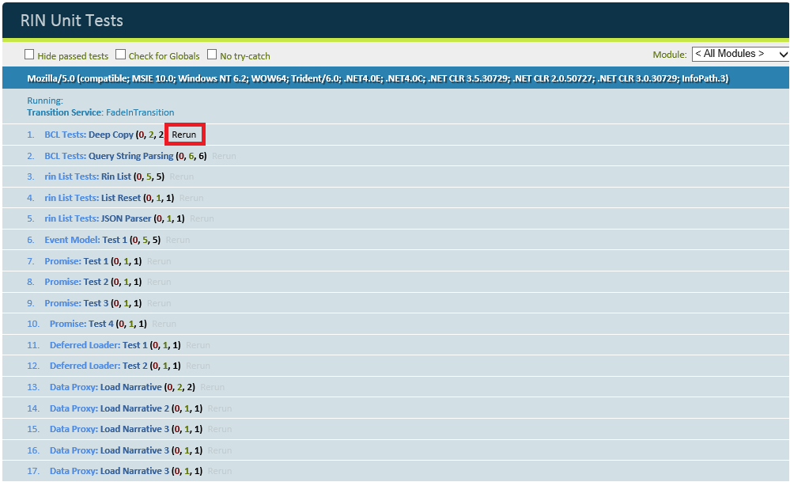

Notes:

1. More information about QUnit and its APIs can be found here.

<http://api.qunitjs.com/>

1. It is important to keep the tests atomic as the QUnit Framework runs the previously failed test cases first before executing other tests.